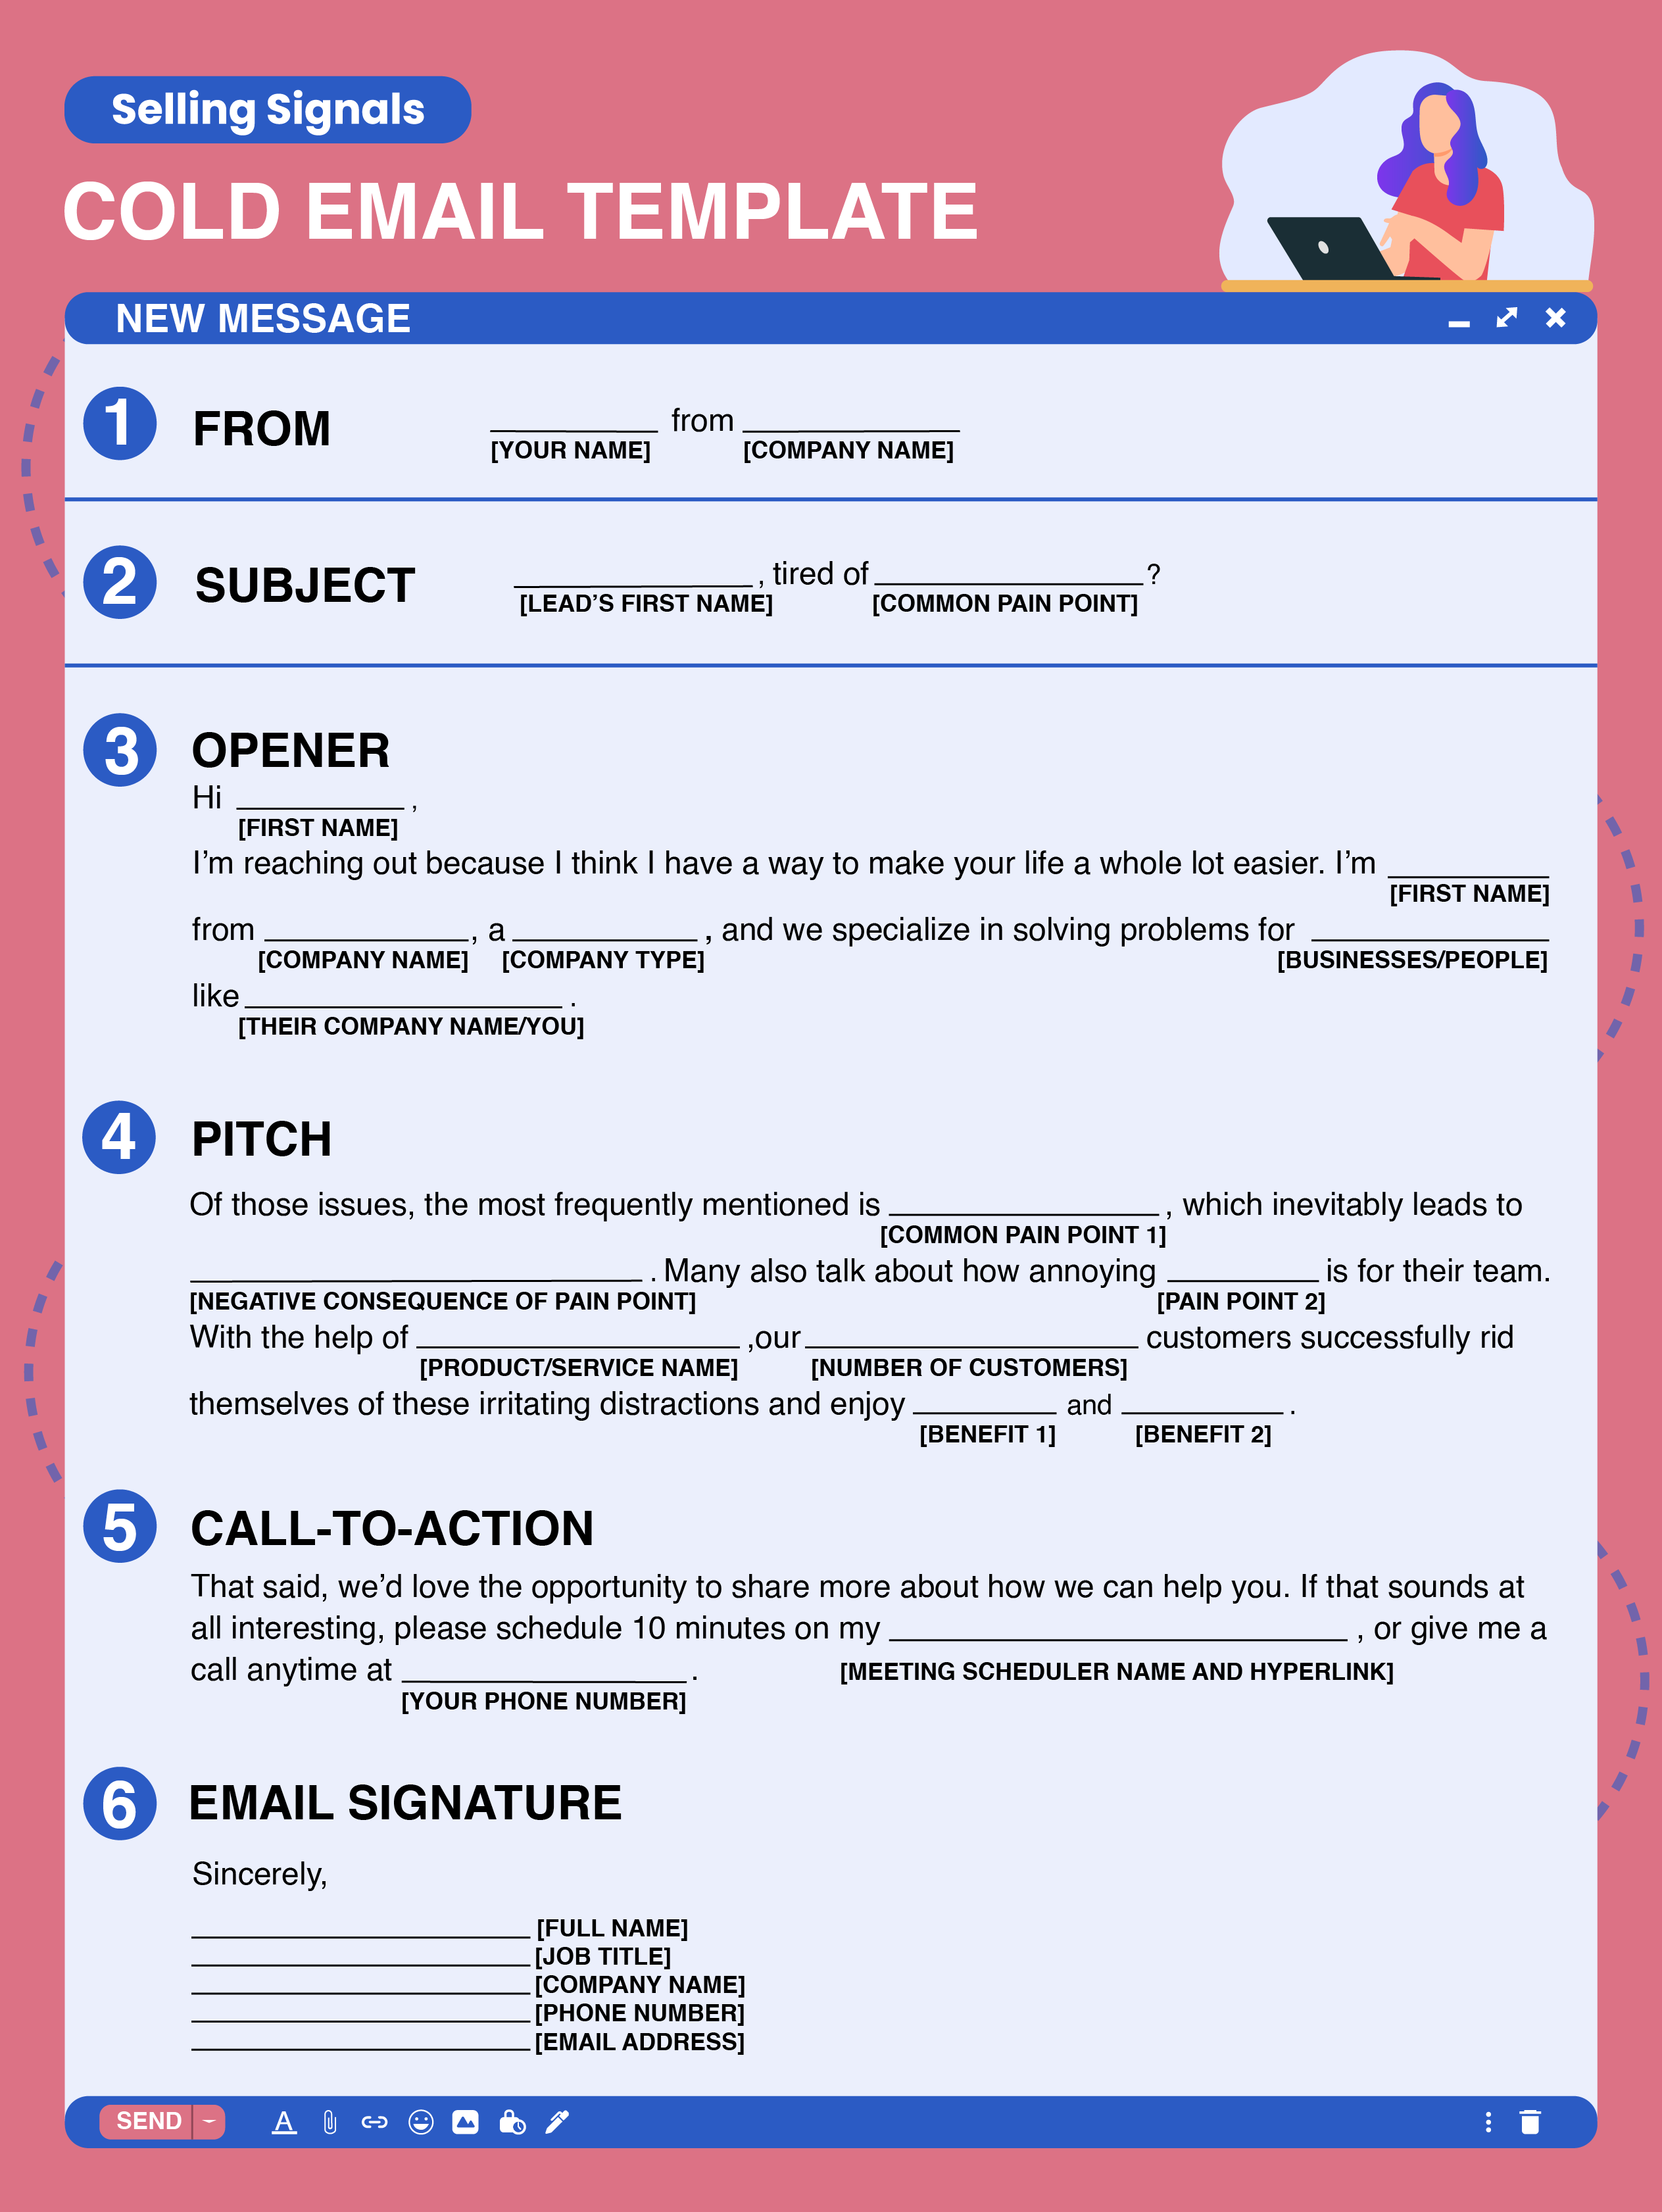

**COLD EMAIL TEMPLATE**

**FROM LINE**

**{First Name}** from **{Company Name}**

**SUBJECT LINE**

**{Lead’s First Name}**, tired of **{Common Pain Point}?**

**OPENER**

Hi **{First Name}**,

I’m reaching out because I think I have a way to make your life a whole lot easier. I’m **{First Name}** from **{Company Name}**, a **{Company Type — e.g., financial services company}**, and we specialize in solving problems for **{Businesses/People}** like **{Their Company Name/You}**.

**PITCH**

Of those issues, the most frequently mentioned is **{Common Pain Point 1}**, which inevitably leads to **{Negative Consequence of Pain Point}**. Many also talk about how annoying **{Pain Point 2}** is for their team. With the help of **{Product/Service Name}**, our **{Number of Customers}** customers successfully rid themselves of these irritating distractions and enjoy **{Benefit 1}** and **{Benefit 2}**.

**CALL-TO-ACTION**

That said, we’d love the opportunity to share more about how we can help you. If that sounds at all interesting, please schedule 10 minutes on my **{Meeting Scheduler Name and Hyperlink}**, or give me a call anytime at **{Your Phone Number}**.

**EMAIL SIGNATURE**

Sincerely,

**{Full Name}**

**{Job Title}**

**{Company Name}**

**{Phone Number}**

**{Email Address}**

Top 12 Cold Email Templates

*COLD EMAILS FOR DIRECT OUTREACH*

**B2B PRODUCT SALES TEMPLATE:**

**From Line: {Your First Name}** the **{Product Type}** Expert

**Subject:** **{Lead’s First Name}**, say goodbye to **{Pain Point}**.

Hi **{First Name}**,

Hope all is well! I’m **{First Name}** from **{Company Name}**. I’m reaching out because I read on **{Company Website/LinkedIn}** that you’re in charge of **{Job Responsibility Relevant to Pain Points You Solve — e.g., *managing a team of 10 sales reps*}**, and I think I have an idea that can help you improve your department’s **{Bottom Line/Efficiency/Other Business Metric}**.

In short, a lot of **{Lead’s Job Title/Department/Company Type}**shave been coming to us lately because they’re struggling with **{Pain Point 1}** and downright sick of **{Pain Point 2}**, which almost always leads to **{Negative Consequence}**.

**{Product Name}**, **{One-Line Product Description — e.g., *a property management software platform}***, eliminates these issues and enables you to **{Benefit 1}** and **{Benefit 2}**.

If you want to learn more about how to solve these problems over a quick phone call, please put five minutes on my **{Meeting Scheduler Name and Hyperlink}**. Looking forward to chatting!

All the best,

**{Full Name}**

**{Job TItle}**

**{Company Name}**

**{Phone Number}**

**{Email Address}**

**B2B SERVICE SALES TEMPLATE:**

**From Line: {Your First Name}** from **{Company Name}**

**Subject: {Lead’s First Name}**, tired of **{Pain Point}**?

Hi **{First Name}**,

**{Your Name}** here from **{Company Name}** —I’m reaching out because I noticed in my research that you head up the **{Department}** over there at **{Lead’s Company Name}**, and I thought I might be able to solve a pertinent problem.

You see, a lot of **{Lead’s Title}**s have mentioned they’re struggling with **{Pain Point — e.g., *ranking their blog posts in Google, finding time to train their salespeople*}**. But, whenever they go look for help, the vendors often **{Problem With Current Vendors — e.g., *fail to capture the brand’s idea in words, use outdated methods, have poor communication, etc.*}**.

At **{Company Name}**, we pride ourselves on delivering top-notch **{Description of Service}** that helps you **{Benefit Related to Pain Point}** thanks to our **{Differentiator — e.g., *use of the latest AI-backed SEO tools*}**. It’s what keeps companies like **{Two Recognizable Brand Names}** with us year after year.

That said, are you interested in learning about how we can help out? If so, please schedule five minutes for a call on my **{Meeting Scheduler Name and Hyperlink}**, and then I can give you a high-level overview of our service. Hoping to hear from you!

All the best,

**{Full Name}**

**{Job TItle}**

**{Company Name}**

**{Phone Number}**

**{Email Address}**

**LINKEDIN COLD MESSAGE TEMPLATE:**

Hi {**Lead’s Name}** — First, I wanted to say how much I enjoy your posts about **{Your Industry}**, especially the one about **{Topic of Latest Post or Share}**. They always give me trends to think about. In the name of reciprocity, I thought it’s about time I returned the favor.

I’m reaching out because my company, **{Company Name}**, has found that the recent **{Industry Shift}** has opened an opportunity to **{Opportunity to Seize — e.g., *capture new market share among Gen Zers*}**. I think we can help **{Lead’s Company}** seize this chance with **{Product/Service}**. Would you like to set up a quick five-minute call to go over the specifics of my idea, maybe **{Suggested Date}** at **{Suggested Time}**?

All the best,

**{Full Name}**

**B2C PRODUCT SALES TEMPLATE:**

**From Line: {Your First Name}**, the **{Clever Title Related to Product — e.g., *back pain wizard, guy with fresh shirts*}**

**Subject:** Sick of **{Pain Point — e.g., *wrinkled shirts, failing to gain muscle, brain fog*}**?

Hey **{First Name}**,

I’m **{Your Name}**, the **{Product Type — *brain supplement, sports car, etc.*}** know-it-all, and I’m well aware that **{Pain Point}** can be a real pain in the rear.

At **{Your Company}**, we specialize in making lives easier with our **{Product Name}**, **{Short Description — e.g., *a cutting-edge nootropic*}** that, unlike others, **{Differentiator — e.g., is all natural}**. It’s helped over **{Number of Customers} {Benefit 1 — e.g., *zap away brain fog*}** and **{Benefit 2}.** Just look at what **{Credibility Builder Name and Hyperlink — e.g., *this scientific study, our testimonials page, this customer*}** said about its effects.

I’d love to tell you more about how this can drastically improve your life. Is there a day or time that works for a quick phone call? Of course, also feel free to reach out to me directly at **{Phone Number}** and let me know what I can do for you.

Thanks,

**{Full Name}**

**{Job TItle}**

**{Company Name}**

**{Phone Number}**

**{Email Address}**

**B2C SERVICE SALES TEMPLATE:**

**From Line: {Your First Name}** @ **{Company Name}**

**Subject:** **{Lead’s First Name}**, quick question!

Hey **{First Name}**,

I’m **{Your Name}** with **{Your Company Name},** a **{Company Description — e.g., *family-owned financial advisory firm*}**, and I was wondering if you might need help with **{Thing You Help With}**?

A lot of our clients were struggling with **{Pain Point — e.g., *saving for their retirement*}**. They just couldn’t **{Reason They Had the Pain Point — e.g., figure out where to consistently put their hard-earned money}**.

After working with us, most are now **{Positive Afterworld — e.g., *on a five-year track to retirement*}**, and finally feeling **{Positive Feeling}**. We’re able to do this by **{Bridge — Brief Description of How Your Service Works}**.

If interested, please give me a call at **{Phone Number}** and allow me to give you a brief overview of the service, or schedule 10 minutes on my **{Meeting Scheduler Name and Hyperlink}**.Hoping to hear from you!

Thanks,

**{Full Name}**

**{Job TItle}**

**{Company Name}**

**{Phone Number}**

**{Email Address}**

*COLD EMAIL TEMPLATES FOR INBOUND LEADS*

**COLD EMAIL TEMPLATE FOR A LEAD WHO DOWNLOADED A LEAD MAGNNET:**

**From Line: {Your First Name}** from **{Company Name}**

**Subject:** **{Lead’s First Name}**, thanks for **{Action the Lead Took}**

Hi **{First Name}**,

**{First Name}** here from **{Company Name}**, the leader in **{Your Company’s Core Competency}.** I was glad to see that you recently downloaded **{Lead Magnet — e.g., *our ebook on managing salespeople*}**, and I hope it provides you with the answers you’re looking for.

If you have any questions along the way, please feel free to reach out to me. Consider me your point of contact here at **{Company Name}**.

Also, since you’re interested in **{Subject of Lead Magnet — e.g, *sales management*}**, I’d feel negligent if I failed to mention our **{Product/Service Related to Lead Magnet — e.g., *sales training course*}**. With it, **{Number of Clients}** **{People/Businesses}** like you have been able to **{Benefit 1}** and **{Benefit 2}.**

If you’d like to learn more about it, please reply to this email with a “yes” and I’ll send over some more information. Or, simply give me a call at **{Phone Number}** and we can get the ball rolling!

All the best,

**{Full Name}**

**{Job TItle}**

**{Company Name}**

**{Phone Number}**

**{Email Address}**

**COLD EMAIL TEMPLATE FOR A LEAD WHO VISITED YOUR WEBSITE:**

**From Line: {Your First Name}** from **{Company Name}**

**Subject:** Thanks for visiting **{Website Name}**!

Hi **{First Name}**,

**{Your Name}** with **{Your Company}** here. Nice to virtually meet you. I saw that you were checking out details on our **{Page the Lead Visited — Typically a Pricing or Product Page, or a Page That Signals Buying Intent}**, and thought I might be of service to answer any of your questions. Some visitors need some guidance when it comes to finding the right package for them.

And I wouldn’t want you to miss out on **{Value Proposition}**.

That said, perhaps you’d be open to a short call to learn more about **{Product/Service Name}**? That way I can also learn a bit more about you and your needs so that I can recommend the right solution.

I’m pretty flexible, so let me know what time works best for you, or feel free to book 10 minutes on my **{Meeting Scheduler Name and Hyperlink}**.

All the best,

**{Full Name}**

**{Job TItle}**

**{Company Name}**

**{Phone Number}**

**{Email Address}**

*COLD EMAIL TEMPLATES FOR FIRST FOLLOW UP*

**EMAIL FOLLOWING UP AFTER AN UNANSWERED COLD CALL:**

**From Line: {Your First Name}** @ **{Company Name}**

**Subject:** **{Lead’s First Name}**, just called!

Hi **{Name}**,

I just gave you a ring, but seem to have missed you. I called because I saw on your website that you’re currently in charge of **{Responsibility}**, and I thought my company could help in that area.

You see, a lot of **{Job Title}**s have been coming to us for help getting rid of their **{Common Pain Point}**, which is giving them **{Negative Consequence}**. Our solution, **{Product/Service Name}**, remedies this by **{How It Works}**. It’s left our **{Number of Customers}** customers with these three amazing results:

* **{Benefit 1}**
* **{Benefit 2}**
* **{Benefit 3}**

If these sound at all desirable to you, please give me a call back at **{Phone Number}** at your earliest convenience. I’d love to share more about how I envision it working for **{Lead’s Company}**. Hoping to hear from you!

All the best,

**{Full Name}**

**{Job TItle}**

**{Company Name}**

**{Phone Number}**

**{Email Address}**

**B2B FIRST FOLLOW-UP TEMPLATE:**

**From Line: {Your First Name}** from **{Company Name}**

**Subject: {Lead’s First Name}**, a better way to **{Process — e.g., *write pitchbooks*}**

Hi **{First Name}**,

I missed you the first time around, but I really think we could help **{Their Business Name}** improve **{Process Your Product/Service Improves}**. With **{Product/Service Name}**, customers often see **{Lead Marketing Statistic — e.g., *an increase of 34% leads per month*}**.

If that sounds beneficial to your company, is there a good time for you to connect over the phone? Otherwise, please give me a call at **{Phone Number}** to see if we’re a good fit.

One last thing — I came across this article about **{Subject Relevant to Their Job}** that you might find interesting. Hope I was right!

All the best,

**{Full Name}**

**{Job TItle}**

**{Company Name}**

**{Phone Number}**

**{Email Address}**

**B2C FIRST FOLLOW-UP TEMPLATE:**

**From Line: {Your First Name}** from **{Company Name}**

**Subject: {Lead’s First Name}**, following up!

Hey **{First Name}**,

Reaching out again to see if I can be of service. I know you’re getting a bunch of robo-emails a day, and wanted to confirm that this is not one of them!

On the contrary, I really think **{Product/Service}** could help you **{Main Value Proposition}**. I’m available for any questions you might have, and I’d love to let you know what we’ve got for you.

If interested, feel free to schedule 10 minutes on my **{Meeting Scheduler Name and Hyperlink}** for us to chat. Or give me a call at **{Phone Number}** for a little more info.

All the best,

**{Full Name}**

**{Job TItle}**

**{Company Name}**

**{Phone Number}**

**{Email Address}**

P.S. I thought you would find **{Article Name}** interesting since it’s all about **{Topic Relevant to Your Target Audience’s Interests}**. Enjoy!

*COLD EMAIL TEMPLATES FOR FINAL FOLLOW-UP*

**B2B FINAL FOLLOW-UP TEMPLATE:**

**From Line: {Your First Name}** @ **{Company Name}**

**Subject:** Still interested in a boost in **{X}**?

Hi **{First Name}**,

Trying you one more time to see if an improvement in **{Process You Help Improve — e.g., *your compliance monitoring approach*}** would benefit your company.

I would hate to leave you hanging without getting on the phone with you to go over the details of our **{Product/Service Name}**. With the **{Benefit}** we’ve accomplished for other customers, it almost seems downright rude not to reach out one last time for a five-minute phone call.

If interested in my final attempt, let’s set up a time to chat. Please find time on my **{Meeting Scheduler Name and Hyperlink}**.

Thanks for your time,

**{Full Name}**

**{Job TItle}**

**{Company Name}**

**{Phone Number}**

**{Email Address}**

**B2C FINAL FOLLOW-UP TEMPLATE:**

**From Line: {Your First Name}** from **{Company Name}**

**Subject:** Anybody home?

Hey **{First Name}**,

Shouting out into the void one more time before I pack my bags and go home. I just don’t want you to miss out on the overwhelming joy that our **{Product}** has to offer.

Seriously, though, I really do think that we at **{Your Company}** have something special. I’m certain that with a few minutes of your time, I could show you how it can **{Benefit — e.g., *help you learn to play guitar like John Mayer in three months*}**.

If you haven’t spam filtered me yet, let’s set up a time to chat. Is there a good day and time for you? As always, also feel free to give me a call at **{Phone Number}** so that my weary fingers can take a break.

All the best,

**{Full Name}**

**{Job TItle}**

**{Company Name}**

**{Phone Number}**

**{Email Address}**